

(AISSCE 2022-2023)

STOCK MANAGEMENT SYSTEM

Computer Science Investigatory Project

Submitted To: Mrs Neeta Panhale

Submitted By: Tanay More

Subject: Computer Science

Class: XII-Science

Roll Number: XIIS26

School: Reliance Foundation School, Lodhivali [English Medium]

CERTIFICATE

This is to certify that the Computer Investigatory Project on "Stock Management System" has been successfully completed by "Mast. Tanay J. More" of class XII-Science in fulfilment of curriculum of Central Board of Secondary Education (CBSE) of Computer Science Leading toward for AISSCE Practical Examination 2022-2023.

_______________ _______________ _______________

External Examiner Internal Examiner Principal

INDEX

|  |  |  |
| --- | --- | --- |
| Serial no. | Description | Page no. |
| 1. | Certificate | 02 |
| 2. | Index | 03 |
| 3. | Acknowledgement | 04 |
| 4. | Preface | 05 |
| 5. | System Requirements | 07 |
| 6. | Source Code | 08 |
| 7. | Output | 17 |
| 8. | Database | 20 |
| 9. | Scope | 21 |
| 10. | Bibliography | 22 |

ACKNOWLEDGEMENT

Apart from my efforts, the success of this project depends largely on the encouragement and guidance of many others. I express my deep sense of gratitude to The Principal, Mr Dhirendra Harbola Sir who has been continuously motivating and extending his helping hand to us. I present my sincere thanks to Mrs Neeta Panhale mam, a guide and a mentor who critically reviewed my project and helped in solving each and every problem, occurred during implementation of the project. I take this opportunity to express my gratitude to the people who have been instrumental in the successful completion of this project. . I would like to extend my thanks to my parents and friends for their valuable guidance in the success and completion of my project.

PREFACE



What is Python?

Python is an open-source (free) programming language that is used in web programming, data science, artificial intelligence, and many scientific applications. Learning Python allows the programmer to focus on solving problems, rather than focusing on syntax. Its relative size and simplified syntax give it an edge over languages like Java and C++, yet the abundance of libraries gives it the power needed to accomplish great things.  It was designed with an emphasis on code readability, and its syntax allows programmers to express their concepts in fewer lines of code.

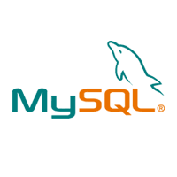What is MySQL?

The management of data in a database system is done by means of a general-purpose software package called a Database Management System (DBMS). MySQL is one such DBMS. A database is a structured collection of data. It may be anything from a simple shopping list to a picture gallery or the vast amounts of information in a corporate network. To add, access, and process data stored in a computer database, you need a database management system such as MySQL.



Stock Management System

The main aim of the project is to develop a Stock Management System software in which all the information regarding the Stock of the organisation will be presented. The program will contain general organisation profile, sales details, purchase details, remaining stock, user login system and many more features. The program will run with Python on the front end while MySQL as the backend tool and provide an efficient, fast, reliable and user-friendly system which is the basic motto behind this exercise.

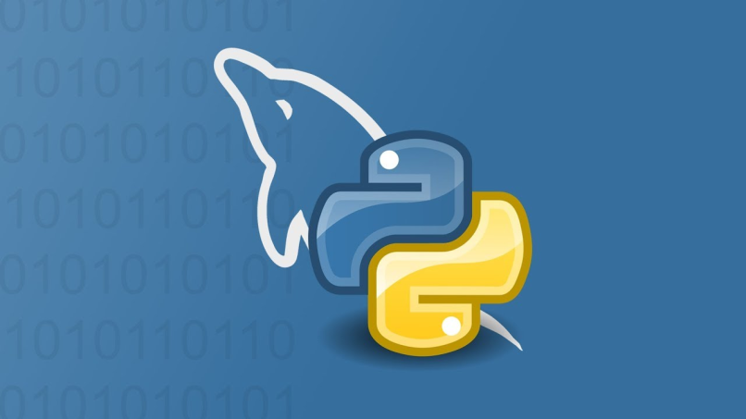

SYSTEM REQUIREMENTS

Software Specification

Operating System : Windows 10 or above

Platform : Python 3.10 or above

Database : MySQL server 5.5 or above

Language : Python

Hardware Specification

Processor : Dual Core or above

Hard Disk : 40 GB

RAM : 1024 MB

**NOTE - For python-MySQL connectivity, following details must be used:**

**Host-localhost ; User-root ; Password-123456 ; Database-stock**

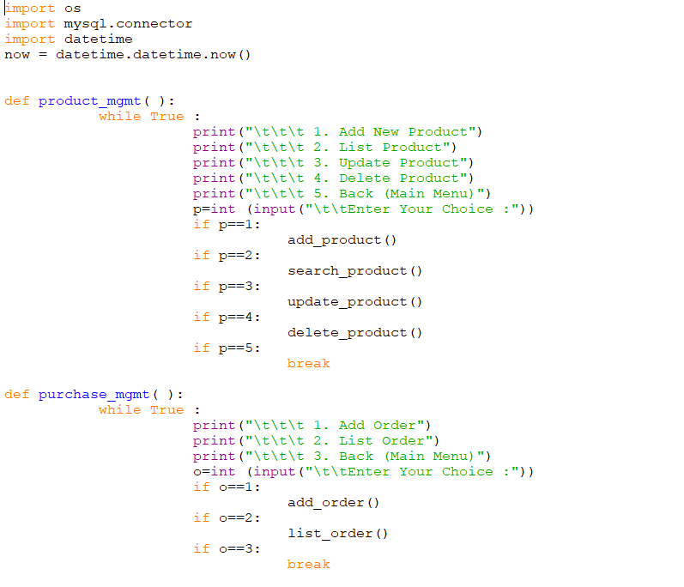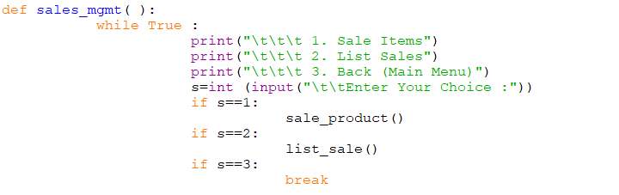SOURCE CODE

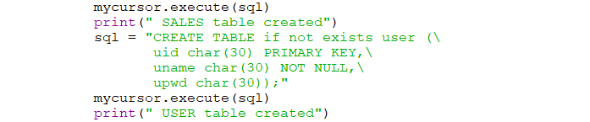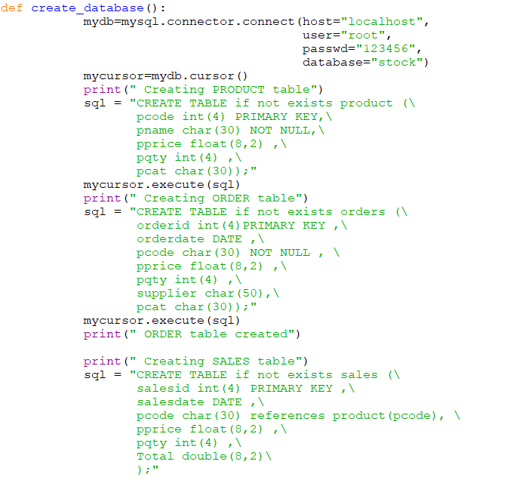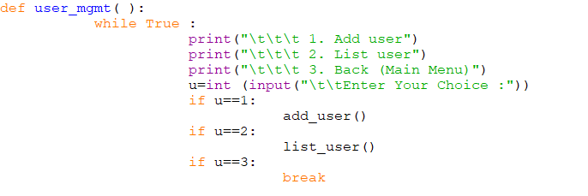

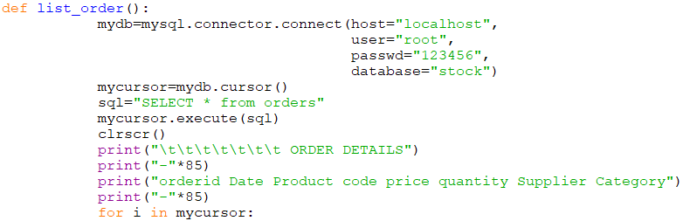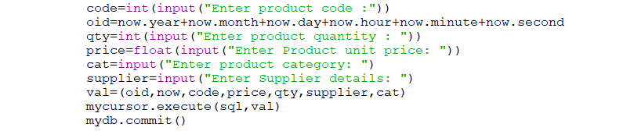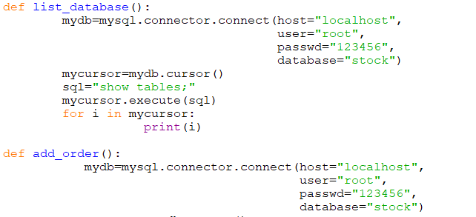



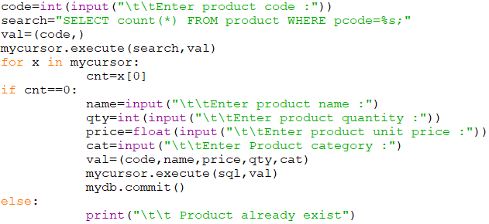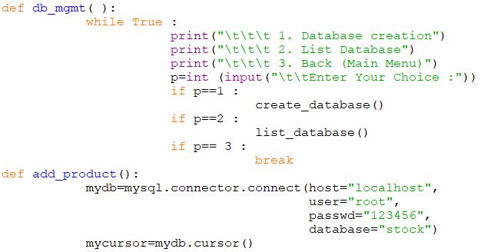

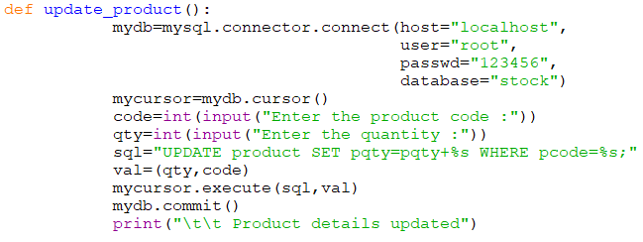

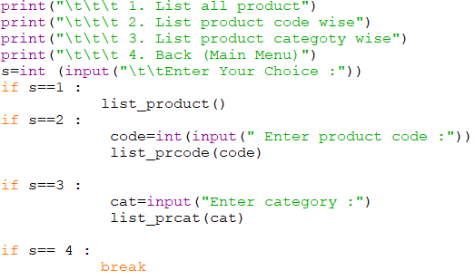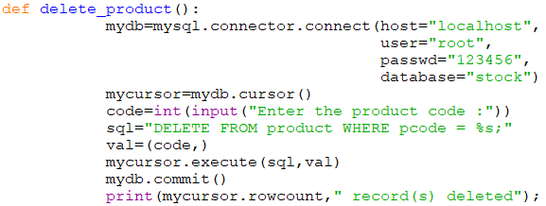

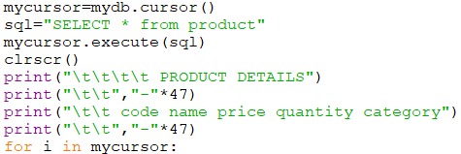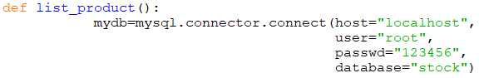



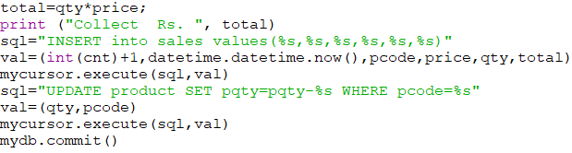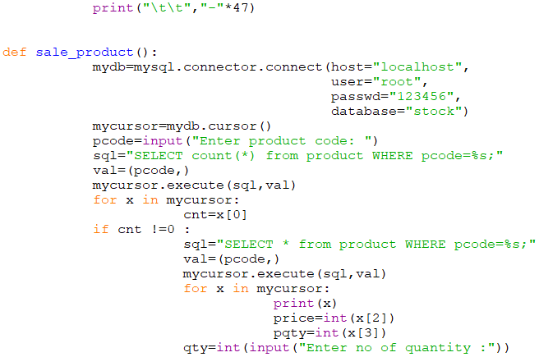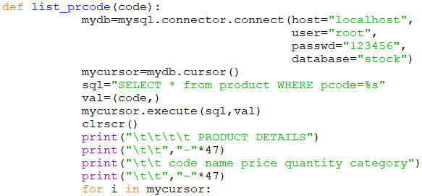

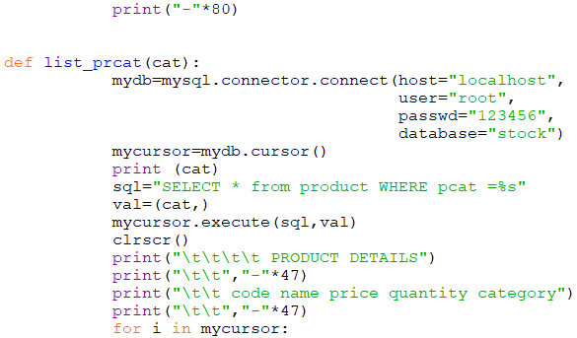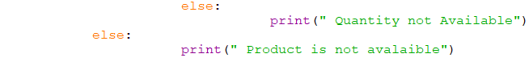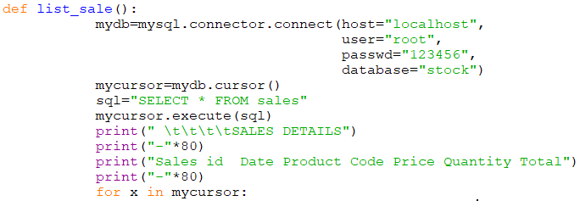



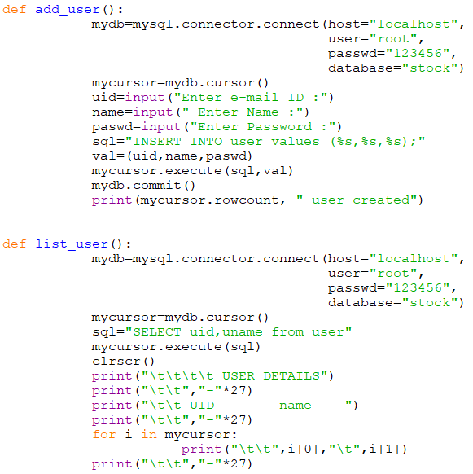

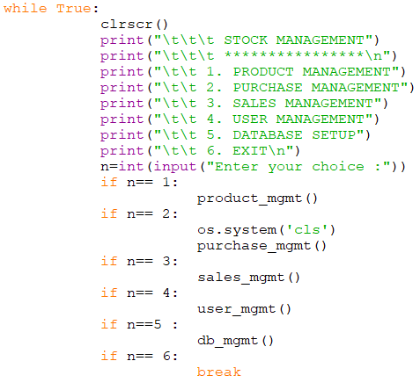

OUTPUT

Database Creation

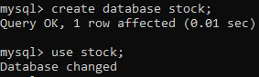

Table Creation

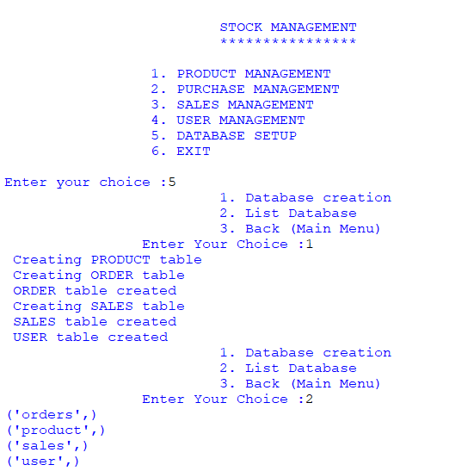

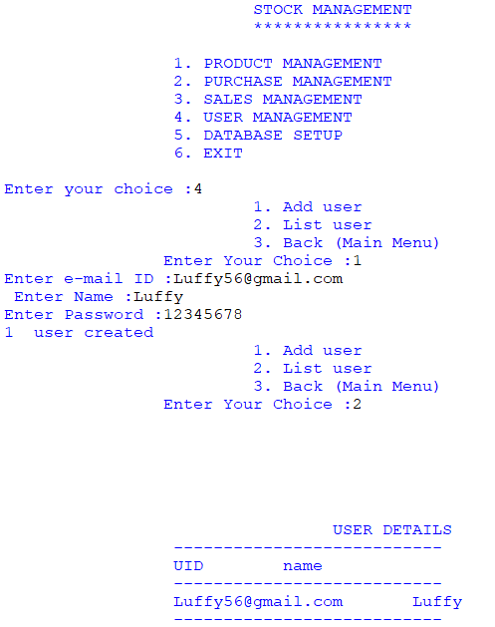User Login

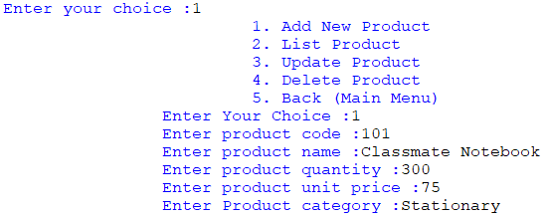Adding a Product

Adding and Listing Order

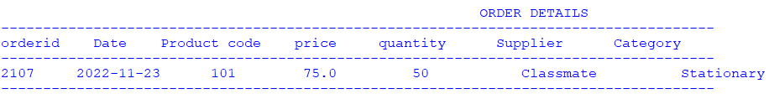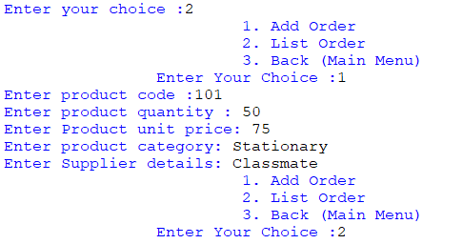

Sales Details

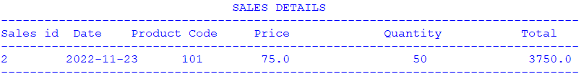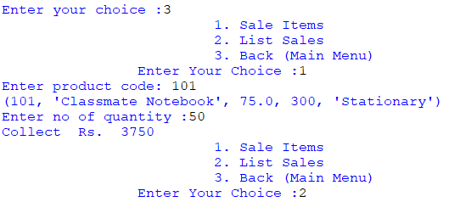

DATABASE

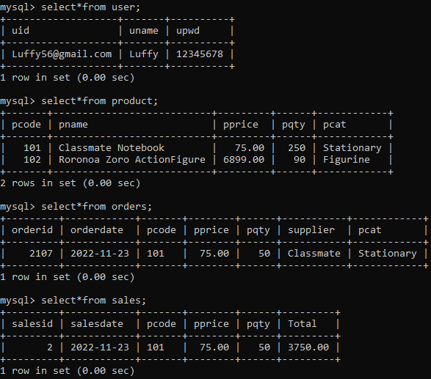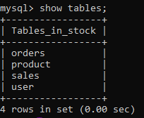Tables